38.44: From Eq. (38.30),
a) 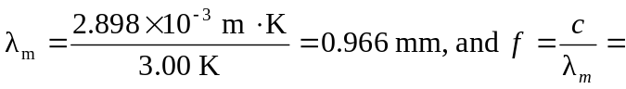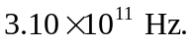
Note that a more precise value of the Wien displacement law constant has been used. b) A factor of 100 increase in the temperature lowers 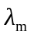by a factor of 100 to 9.66 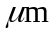 and raises the frequency by the same factor, to 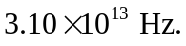 c) Similarly,